**Task**

Question 1:- Create Table Name: - Student and Exam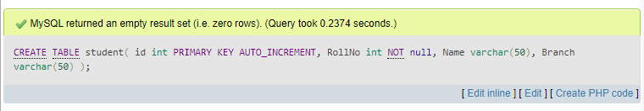

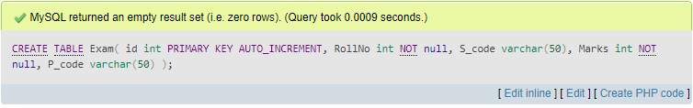

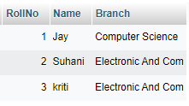 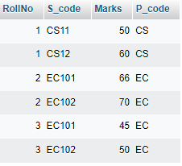

Question 2: - Create table given below

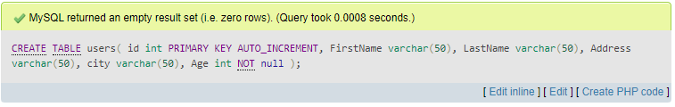

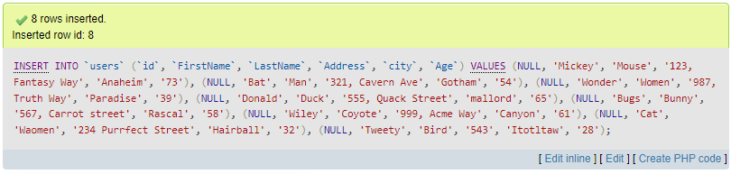

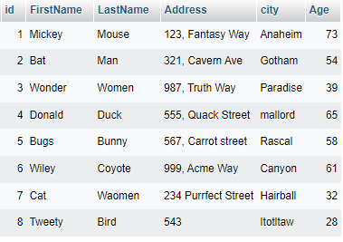

Question 03:- Create table given below: Employee and Incentive

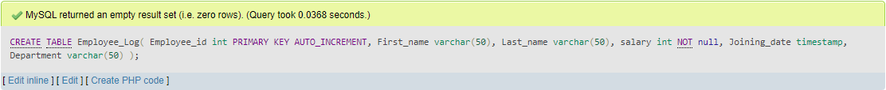

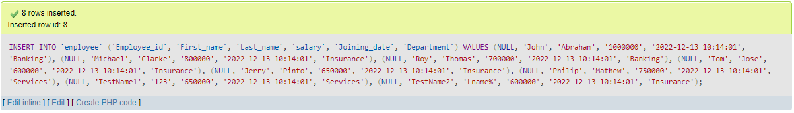

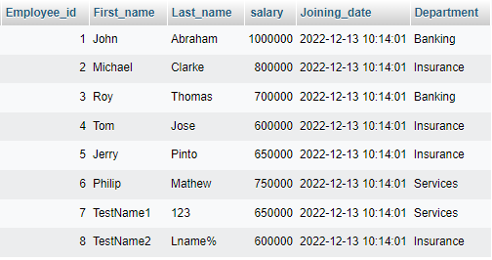

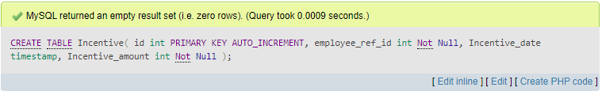

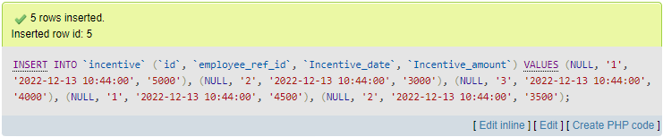

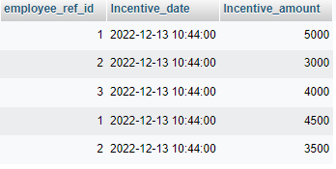

Q3 -A: - Get First_Name from employee table using Tom name “Employee Name”.

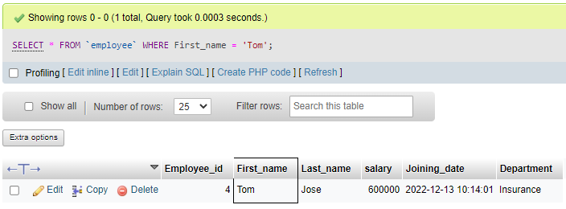

Q3 -B:- Get FIRST_NAME, Joining Date, and Salary from employee table.

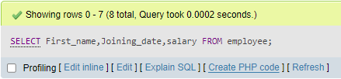

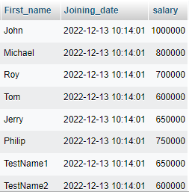

Q3-C:- Get all employee details from the employee table order by First_Name Ascending and Salary descending?

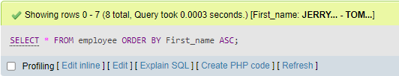

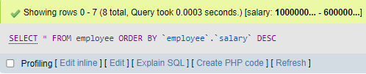

First_name Ascending Salary Descending

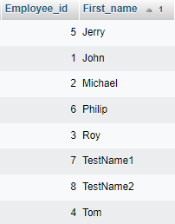 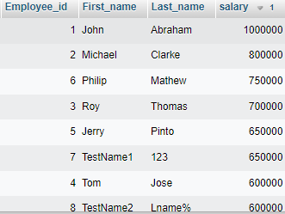

Q3-D:- Get employee details from employee table whose first name contains ‘J’.

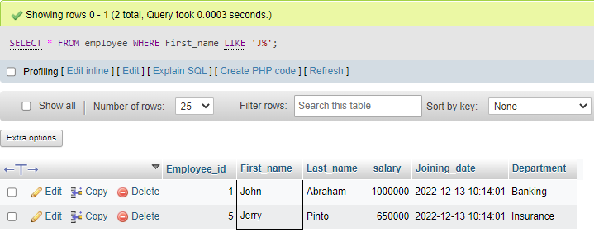

Q3-E:- Get department wise maximum salary from employee table order by salary ascending?

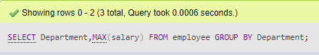

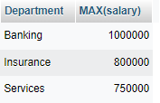

Q3-F:- Select first_name, incentive amount from employee and incentives table for those employees who have incentives and incentive amount greater than 3000

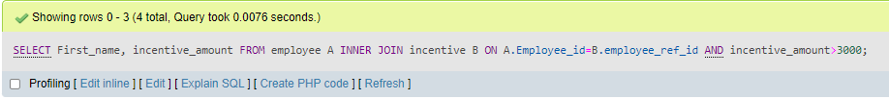

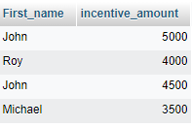

Q3-G:- Create After Insert trigger on Employee table which insert records in view table



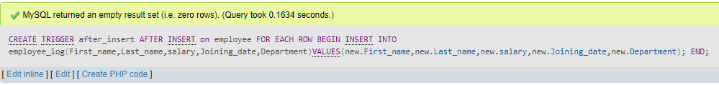

Employee Table insert Data

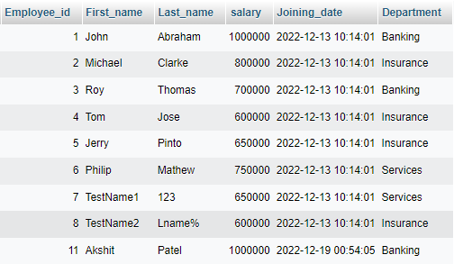

Employee_log table with Trigger action using After Insert Query



Quest 04:- Create table given below: Salesperson and Customer

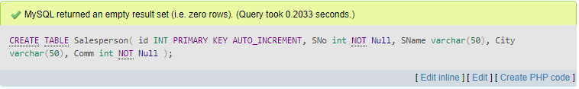

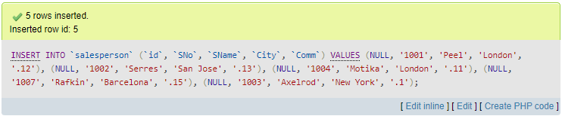

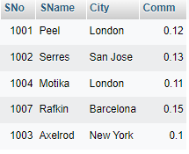

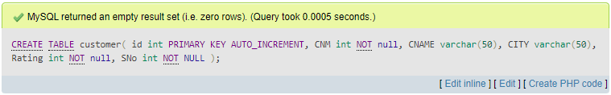

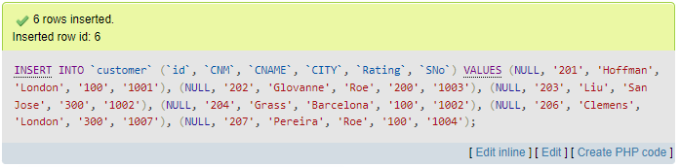

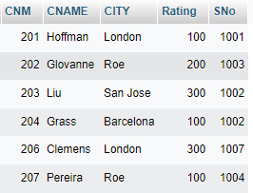



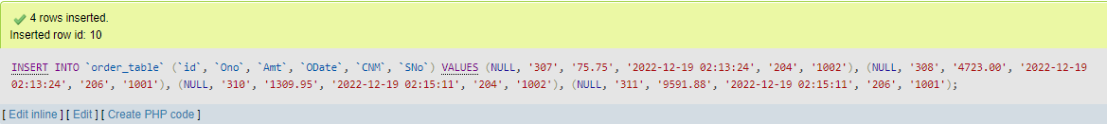

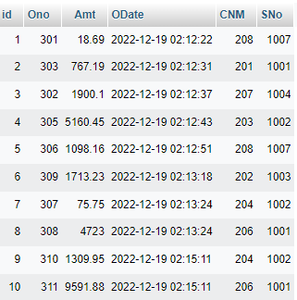

Q4-A:- All orders for more than $1000.

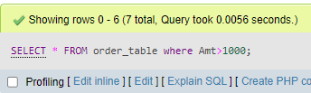

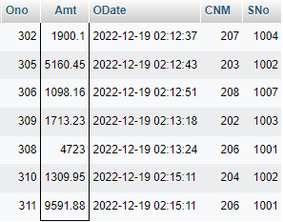

Q4-B:- Names and cities of all salespeople in London with commission above 0.12

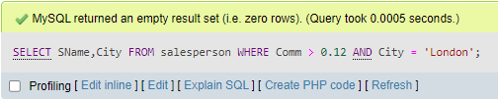

Q4-C:- All salespeople either in Barcelona or in London

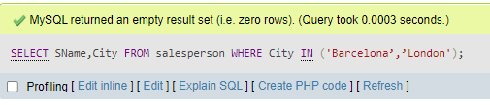

Q4-D:- All salespeople with commission between 0.10 and 0.12. (Boundary values should be excluded).

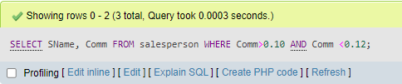

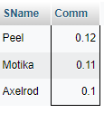

Q5-E:- All customers excluding those with rating <= 100 unless they are located in Rome

